BOX PLOTS
Pearson Edexcel – Thursday 4 June 2020 - Paper 2 (Calculator) Higher Tier
1.
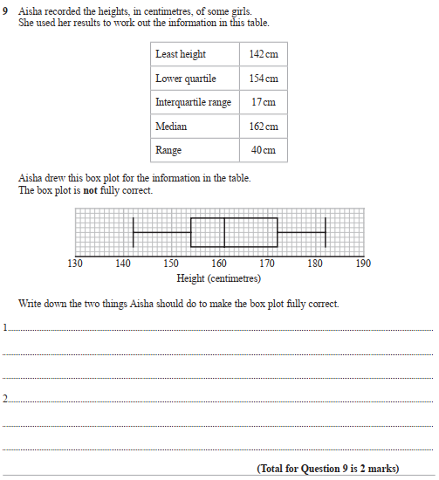

Pearson Edexcel - Tuesday 6 November 2018 - Paper 1 (Non-Calculator) Higher Tier
2.
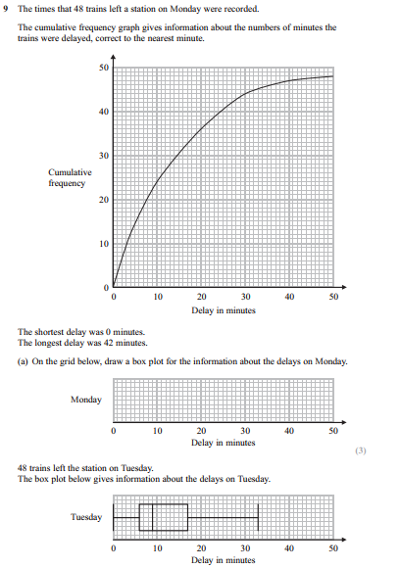
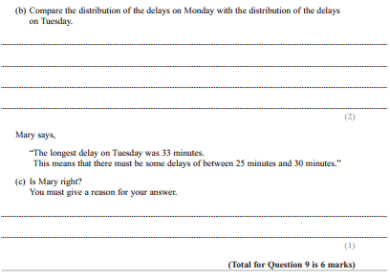

Pearson Edexcel - Thursday 24 May 2018 - Paper 1 (Non-Calculator) Higher Tier
3.
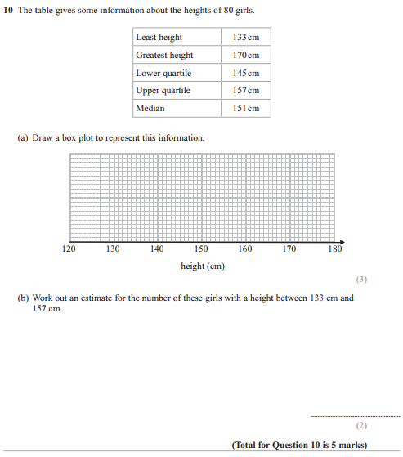
Pearson Edexcel - Thursday 2 November 2017 - Paper 1 (Non-Calculator) Higher Tier
4.
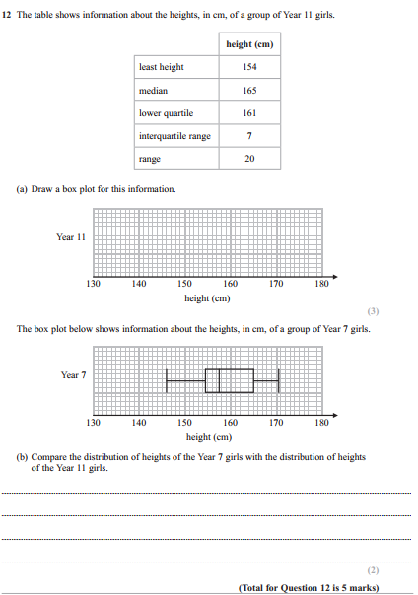

Pearson Edexcel - Tuesday 13 June 2017 - Paper 3 (Calculator) Higher Tier
5.
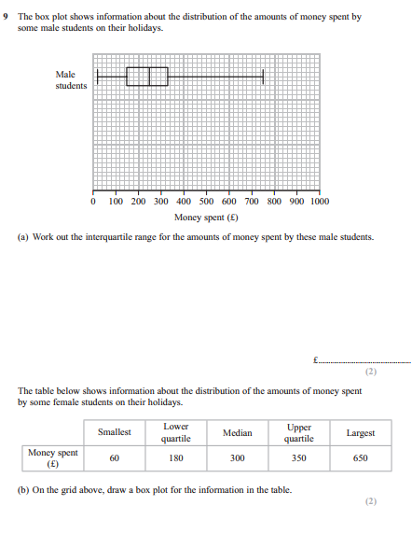
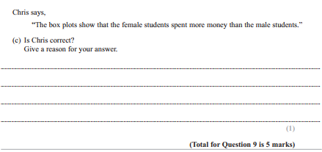
Pearson Edexcel - Sample Paper 1 - (Non-Calculator) Higher Tier
6.
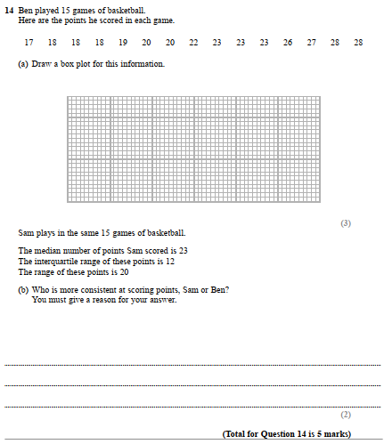

Pearson Edexcel - Thursday 26 May 2016 - Paper 1 (Non-Calculator) Higher Tier
7.
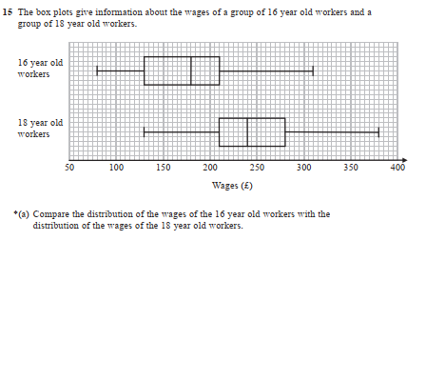
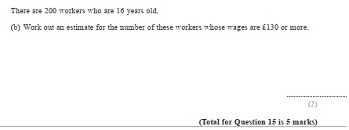

Pearson Edexcel - Friday 6 November 2015 - Paper 2 (Calculator) Higher Tier
8.
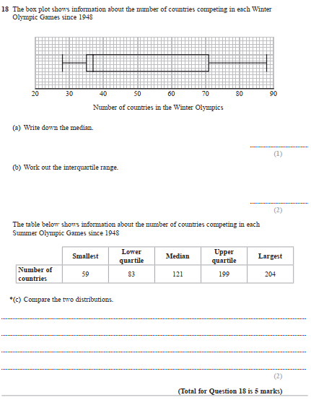

Pearson Edexcel - Wednesday 5 November 2014 - Paper 1 (Non-Calculator) Higher Tier
9.
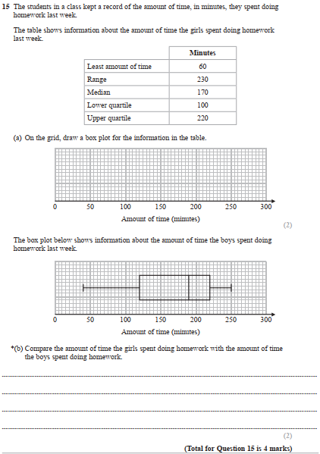

Pearson Edexcel - Monday 9 June 2014 - Paper 1 (Non-Calculator) Higher Tier
10.
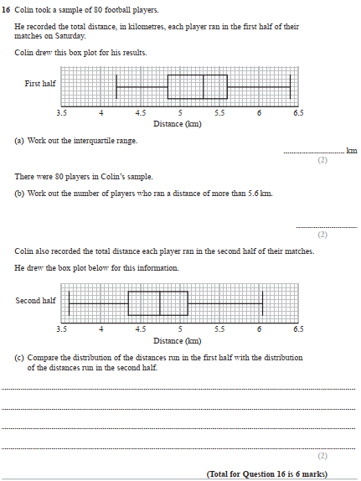

Pearson Edexcel - Wednesday 6 November 2013 - Paper 1 (Non-Calculator) Higher Tier
11.
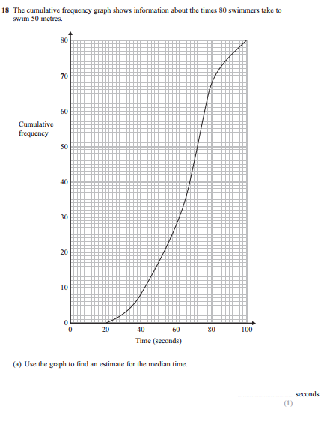
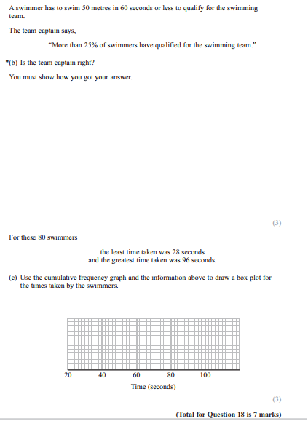

Pearson Edexcel - Friday 14 June 2013 - Paper 2 (Calculator) Higher Tier
12.
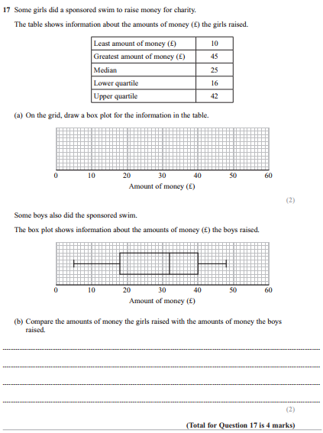

Pearson Edexcel - Monday 4 March 2013 - Paper 2 (Calculator) Higher Tier
13.
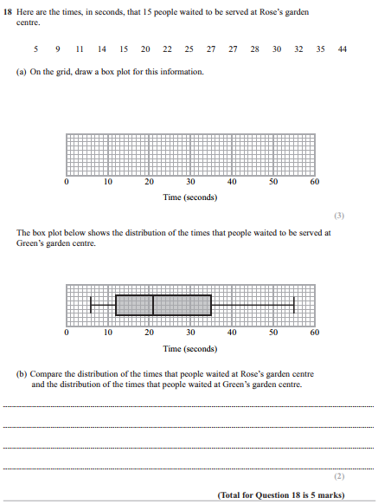

Pearson Edexcel - Tuesday 6 November 2012 - Paper 1 (Non-Calculator) Higher Tier
14.
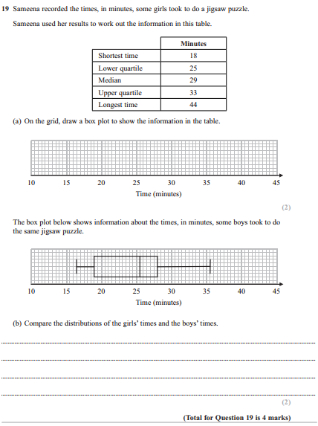

Pearson Edexcel - Monday 11 June 2012 - Paper 1 (Non-Calculator) Higher Tier
15.
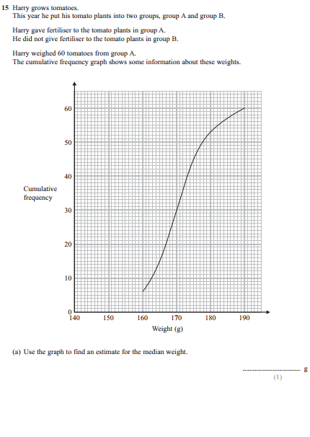
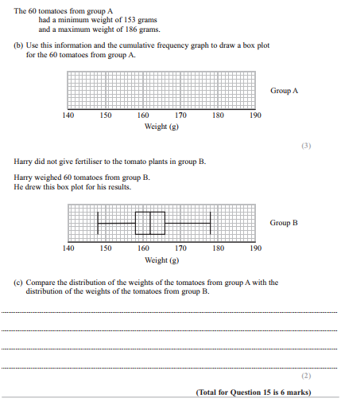

Pearson Edexcel - Friday 2 March 2012 - Paper 3 (Non-Calculator) Higher Tier
16.
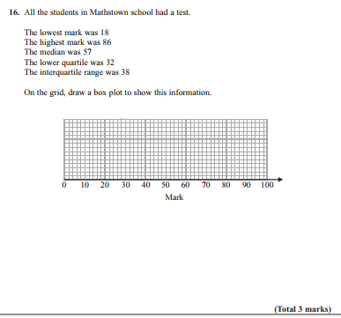

Pearson Edexcel - Monday 14 November 2011 - Paper 4 (Calculator) Higher Tier
17.
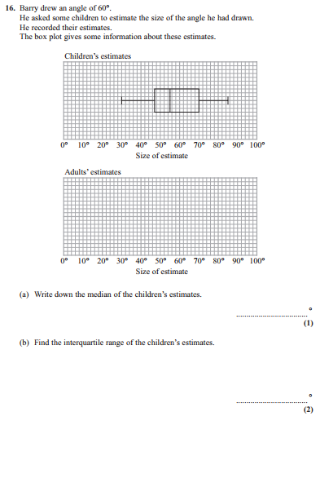
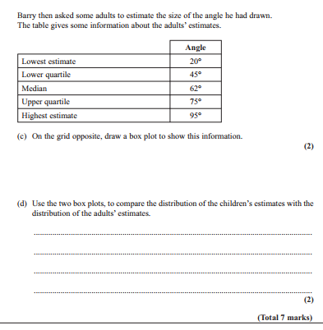

Pearson Edexcel - Monday 6 June 2011 - Paper 3 (Non-Calculator) Higher Tier
18.
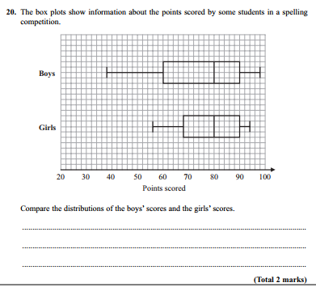

Pearson Edexcel - Tuesday 9 November 2010 - Paper 3 (Non-Calculator) Higher Tier
19.
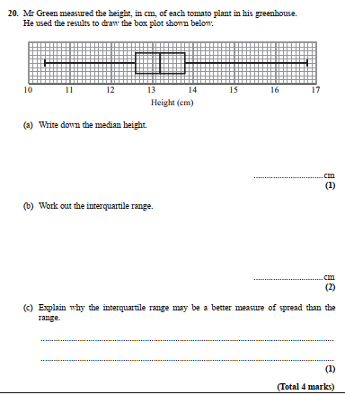
Pearson Edexcel - Thursday 5 November 2009 - Paper 3 (Non-Calculator) Higher Tier
20.
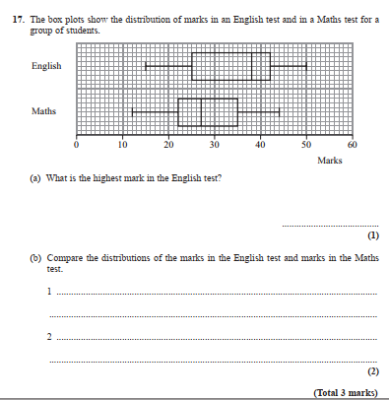

OCR GSCE – Tuesday 3 November 2020 – Paper 4 (Calculator) Higher Tier
21.
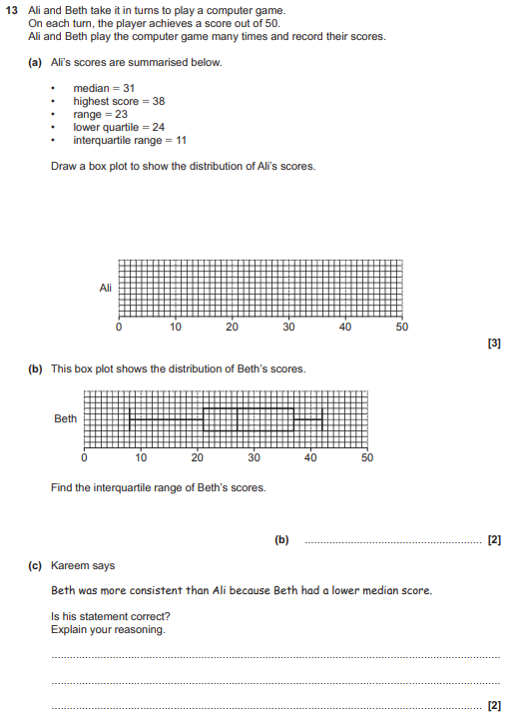

OCR GSCE – Thursday 7 November 2019 – Paper 5 (Non-Calculator) Higher Tier
22.
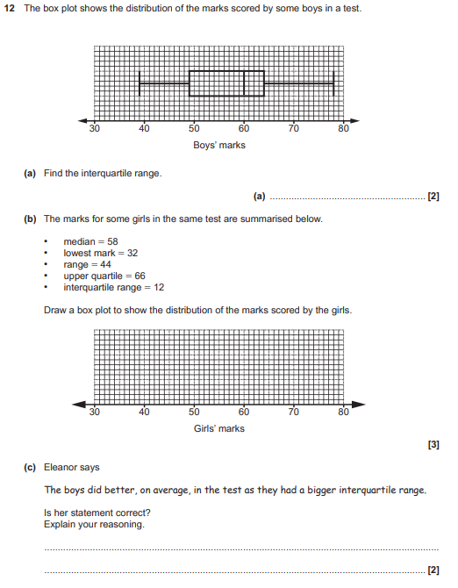

OCR GSCE – Tuesday 6 November 2018 – Paper 4 (Calculator) Higher Tier
23.
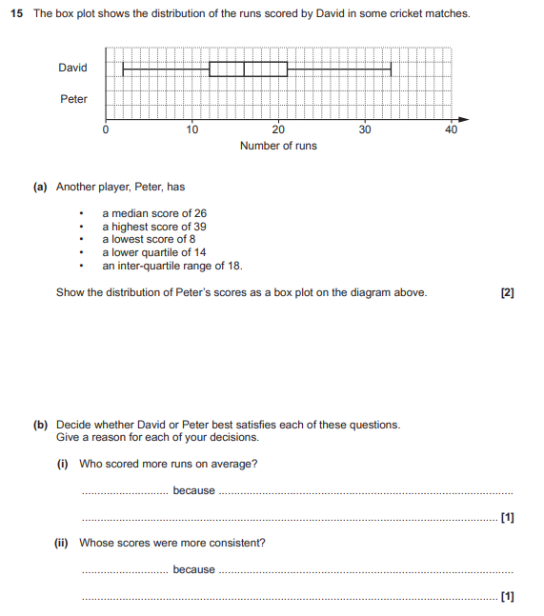

OCR GSCE – Tuesday 12 June 2018 – Paper 6 (Calculator) Higher Tier
24.
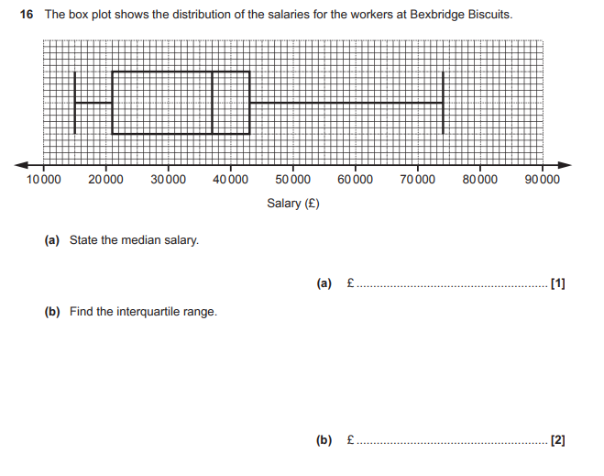
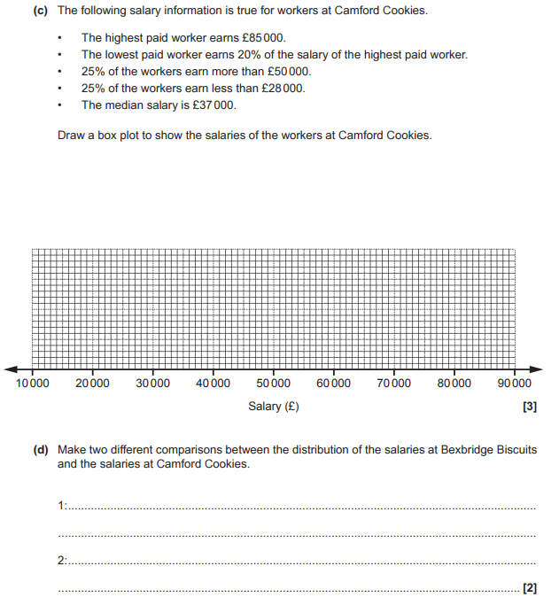

OCR GSCE – Sample Papers – Paper 5 (Non - Calculator) Higher Tier
25.
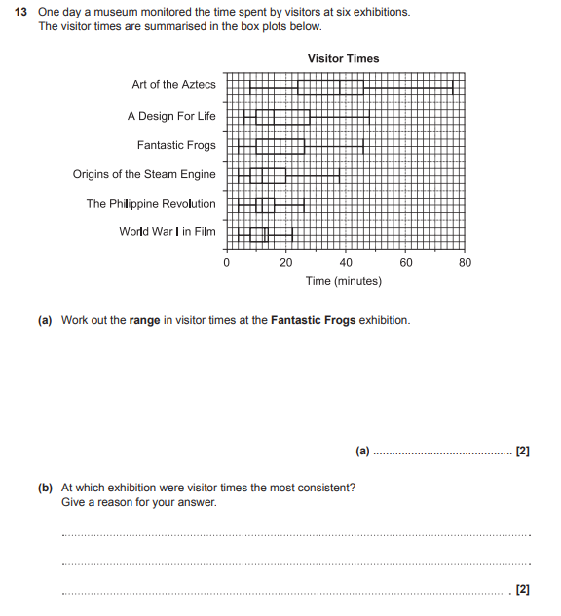
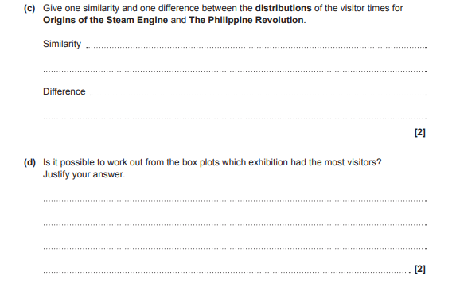
AQA GSCE – Thursday 8 June 2020 – Paper 3 (Calculator) Higher Tier
26.
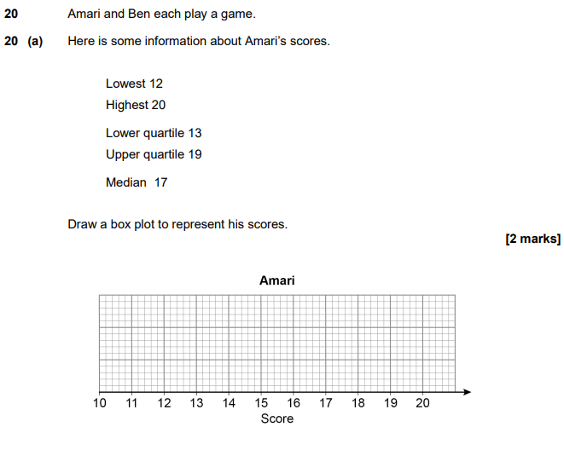
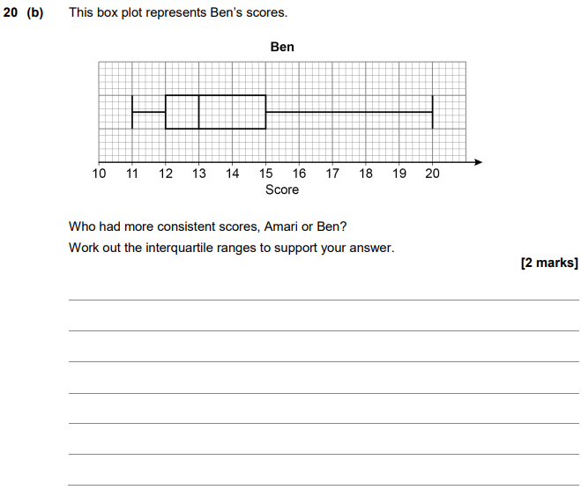

AQA GSCE – Tuesday 11 June 2019 – Paper 3 (Calculator) Higher Tier
27.
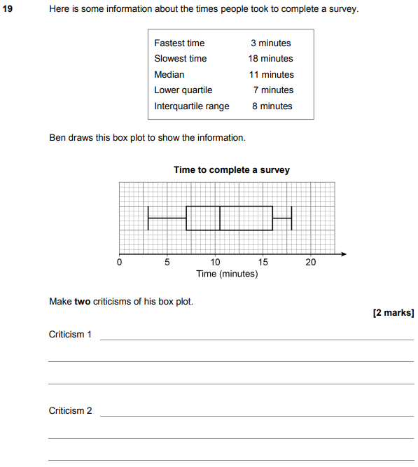

AQA GSCE – Tuesday 6 November 2018 – Paper 1 (Non - Calculator) Higher Tier
28.
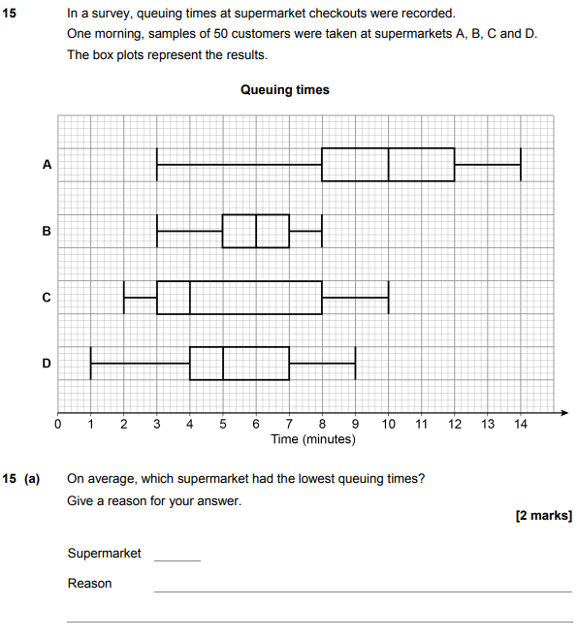
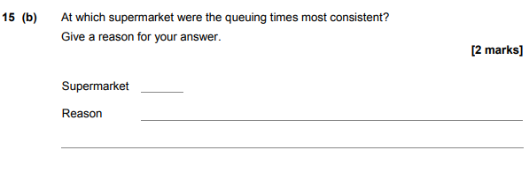
AQA GSCE – Wednesday 8 November 2017 – Paper 3 (Calculator) Higher Tier
29.
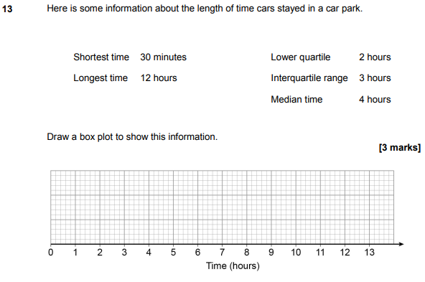

AQA GSCE – Thursday 8 June 2017 – Paper 2 (Calculator) Higher Tier
30.
